# Conclusion

The idea behind Project Portal was to create a simple tool that would allow project teams to collaborate and share information quickly and easily. Project Portal was to include a map, a calendar, and a way to share files. A map was necessary because most of the projects at the Department of Natural Resources (DNR) are primarily location based. A calendar was requisite in order to have all of the project associated events in one location. The file browser was requested in order to create a place where project related files can be effortlessly shared.

In the planning phase, it was determined that Project Portal should be created as a web application. According to the requirements for Project Portal, the web platform to be used is Microsoft’s ASP.NET. The version of .NET being using on Project Portal uses ASP for the code being delivered to the users and employs C# to handle the server-side code. On the hardware side, Project Portal is running on a Windows Server. The user can access Project Portal through any of the mainstream web browsers, for example: Internet Explorer, Google Chrome, or Mozilla Firefox. The security for Project Portal is handled through a login requirement to access any of the pages with information on them. The user account control is handled by the State of Alaska’s (SOA) lightweight directory access protocol (LDAP) system.

Before starting Project Portal, I had no experience with .NET. Consequently, there was a fairly steep learning curve in getting this project started. Not only did I have to learn .NET, I also had to learn how to use Microsoft’s development software: Visual Studio. Once I got through the initial learning stages, I really enjoyed learning and getting some experience using .NET. This allows me to be a more well-rounded programmer as well as makes me more marketable to employers.

## Implications / Recommendations for Future Development

The impetus for Project Portal was that a project manager asked my boss if there are any software solutions that would allow his project teams to communicate easier. Therefore, my boss asked me to create a team communication tool that ended up becoming Project Portal. The final goal for project Portal is that it would be used by various project teams for project related communications. One of the design requirements for Project Portal was that it be mostly a template design so that it could be adapted to a wide variety of projects thus allowing for easy creation and maintenance. Project Portal will make project teams more productive by allowing for smooth and straightforward collaboration between team members.

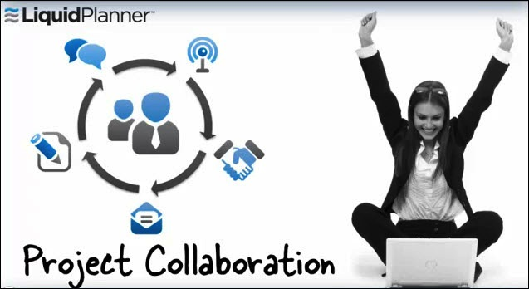

Figure 5.1 - Project Collaboration Image from www.liquidplanner.com

Several of the initial recommendations that I had for future development, I was able to fit into the project. Those recommendations included using the LDAP system to login for security and using the Microsoft exchange server to control the calendar. The main recommendation I have for future development is to modify how the Telerik tools display the calendar. There are some oddities in the way that it displays some of the calendar features. Other recommendations would include adding a team manager’s report and a notebook like feature. A team manager’s report would be similar to a blog and would allow the manager to “post” project updates. The notebook feature would be a space where any team member could simply post ideas or comments about the project. This could include simple text or could somehow allow for posting of things like pictures, drawings, or web page snippets.

## Conclusion

Project Portal was a great real world project for me. The fact that it was actually going to be used provided me with lot of good motivation. I was able to use it as both a senior project to complete my degree and a project for work to demonstrate my abilities. Project Portal granted me the ability to learn .NET as well as how the front-end and back-end work together to display the information to user. Project Portal will be a great asset to project teams at DNR giving them the ability to quickly and simply share project related information. Project Portal and programs similar to it will become increasingly important as efficient team communication and collaboration have become essential in the today’s business world.